local or remote databases

🌍 What Is a Local or Remote Database?
# Source: AI Source: Provided by: [Data Path: Persons Table -> ID Column: 1, Name_En Column: Motasem Essam] -> From: [ChatGPT] on [6/10/2026]
These terms describe where the database is located relative to your computer (or the application trying to access it):

🖥️ Local Database
# Source: AI Source: Provided by: [Data Path: Persons Table -> ID Column: 1, Name_En Column: Motasem Essam] -> From: [ChatGPT] on [6/10/2026]
- 📍 Stored on your own computer (the same machine you’re working on)
- ✅ Faster access (no internet needed)
- 🛠️ Great for development, testing, learning, or small apps
Example:
You install MySQL on your laptop and access it using DBeaver or HeidiSQL.
Hostname = localhost or 127.0.0.1

🌐 Remote Database
# Source: AI Source: Provided by: [Data Path: Persons Table -> ID Column: 1, Name_En Column: Motasem Essam] -> From: [ChatGPT] on [6/10/2026]
- 📡 Stored on another computer (usually a server)
- Requires network or internet connection to access
- 🔐 Often used in production systems, websites, cloud apps
Example:
A company hosts a PostgreSQL database on AWS Cloud.
You connect from your office computer using its IP or domain name like db.example.com

🔄 Quick Comparison
# Source: AI Source: Provided by: [Data Path: Persons Table -> ID Column: 1, Name_En Column: Motasem Essam] -> From: [ChatGPT] on [6/10/2026]
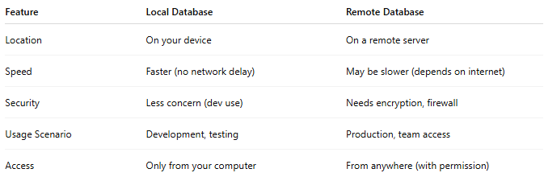
Feature | Local Database | Remote Database
Location | On your device | On a remote server
Speed | Faster (no network delay) | May be slower (depends on internet)
Security | Less concern (dev use) | Needs encryption, firewall
Usage Scenario | Development, testing | Production, team access
Access | Only from your computer | From anywhere (with permission)

🧪 Use Case Examples
# Source: AI Source: Provided by: [Data Path: Persons Table -> ID Column: 1, Name_En Column: Motasem Essam] -> From: [ChatGPT] on [6/10/2026]
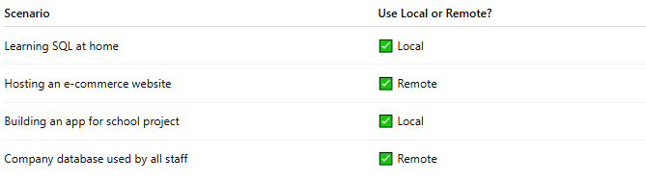
Scenario | Use Local or Remote?
Learning SQL at home | ✅ Local
Hosting an e-commerce website | ✅ Remote
Building an app for school project | ✅ Local
Company database used by all staff | ✅ Remote

